OLNA Skill: Applies the four operations to solve problems in measurement contexts

- A rectangular patio is 8 metres long and 3 metres wide.

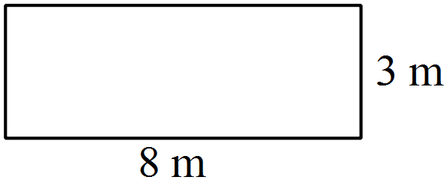

- What is its area in square metres?

- Calculate it’s area in square centimetres.

- The patio is going to be tiled. Each tile is a 10 cm by 10 cm square. How many tiles will be needed?

- A swimming pool has a rectangular path around it as shown in the diagram below. The dimensions of the pool are 6 m by 4 m and the path is 1 m wide.
- What is the area of the path?
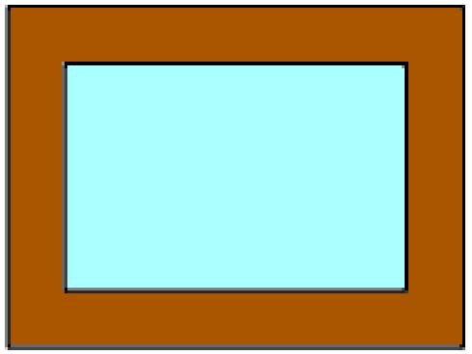

- Paving costs $15 per square metre. What is the cost of paving the path?

Terminology:

- The area of a rectangle can be calculated by multiplying its length by its width.
- Area is always measured in square units such as m² or cm².

